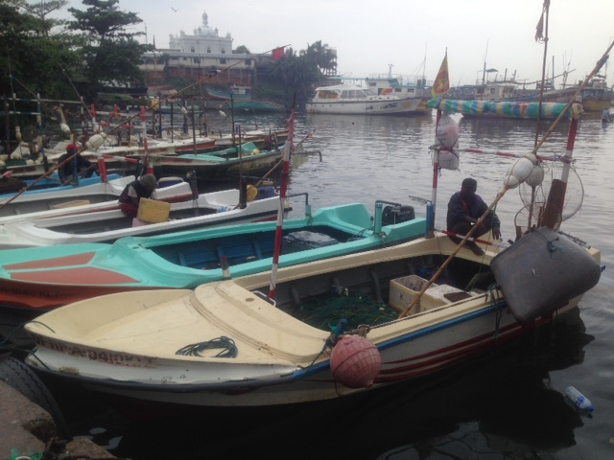  Figure 1: FRP boats which catch neritic tuna in Beruwela | Figure 2: Frigate tuna being auctioned in the harbour
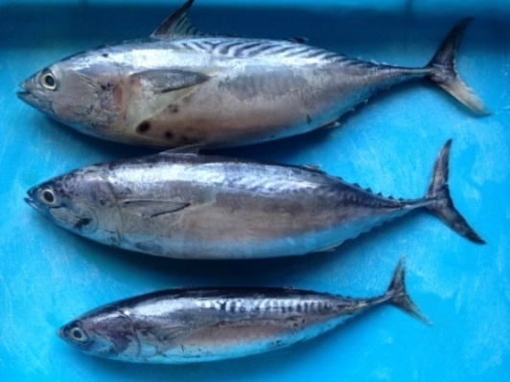  Figure 3: The 3 species of neritic tuna studied | 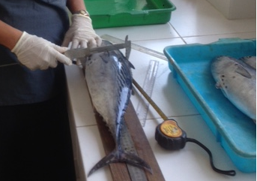  Figure 4: Measuring of head depth
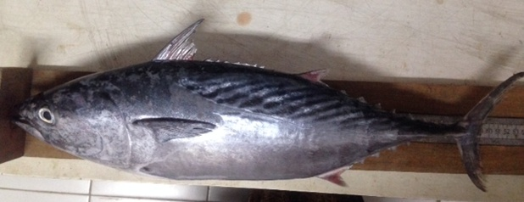

Figure 5: Measuring of length of Kawakawa

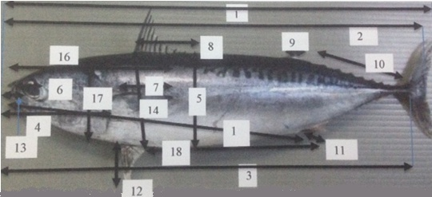

Figure 6: Length measurement taken of the fish

Figure 7: Lab analysis | Figure 8: Dissection of a fish
Figure 9: Gonads of different stages | Figure 10: Gel photograph showing PCR products run with a marker

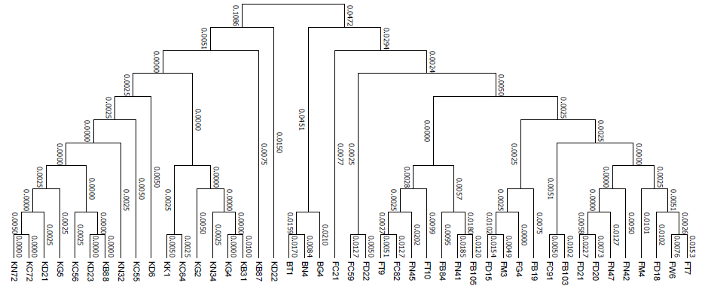

Figure 11: Phylogenetic tree drawn for sequenced samples

