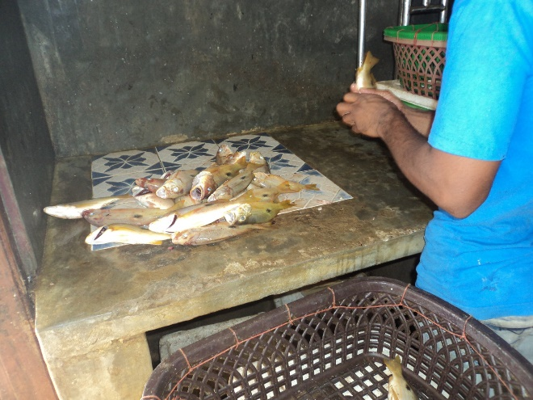

**Figure 1:** Edible reef fish at Chilaw

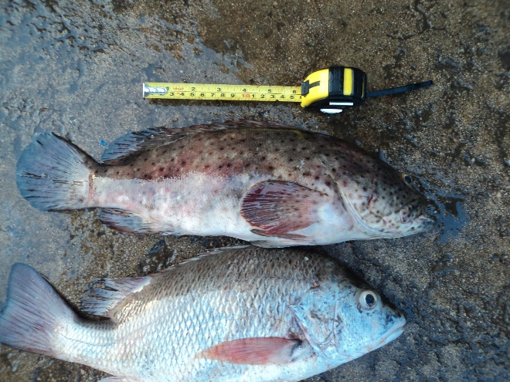

**Figure 2:** *Epinephelus malabaricus* (Bloch & Schneider, 1801) (at top) – (Negombo)

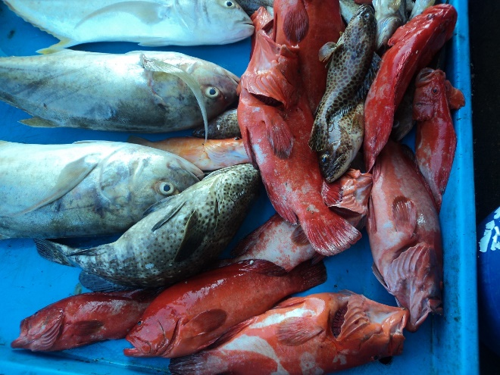

**Figure 3:** Reef fishes at Beruwala

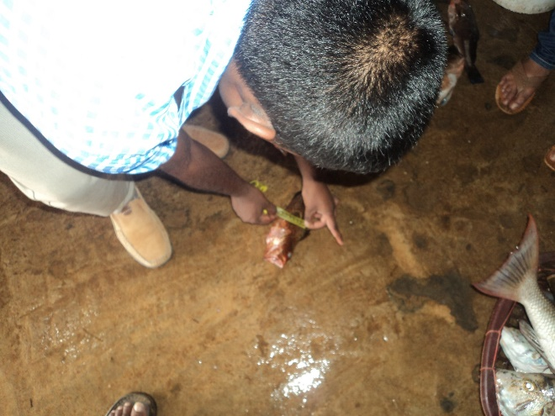

**Figure 4:** Data collection in the field - Chilaw

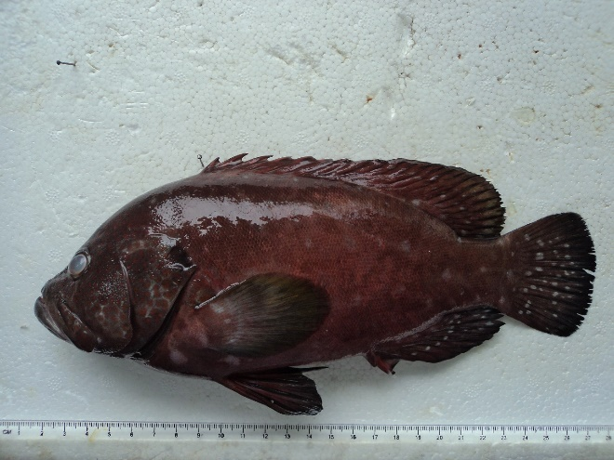

**Figure 5:** Lab analysis: *Cephalopholis sonnerati*

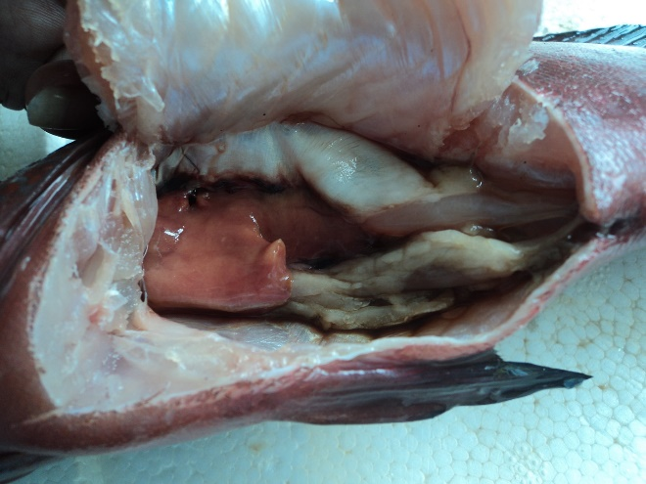

**Figure 6:** Lab analysis: dissection of the fish (*Cephalopholis sonnerati)*

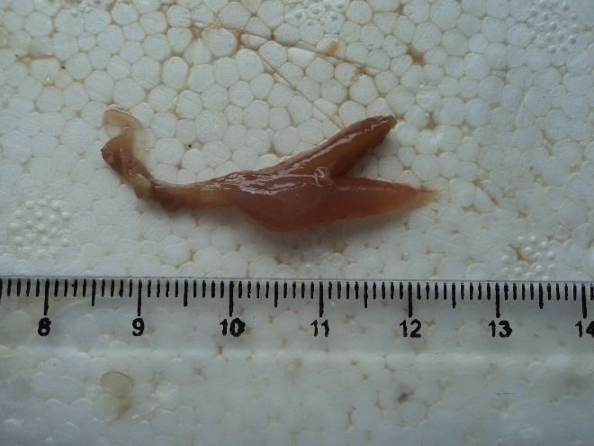

**Figure 7:** Lab analysis: gonads of the fish (*Cephalopholis sonnerati)*

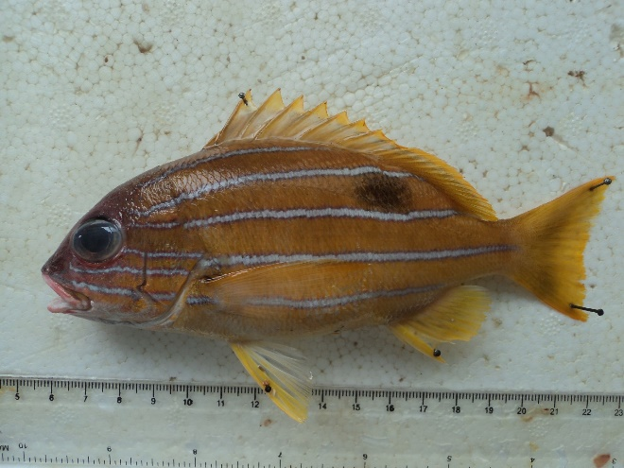

**Figure 8:** Lab analysis: *Lutjanus quinquelineatus*

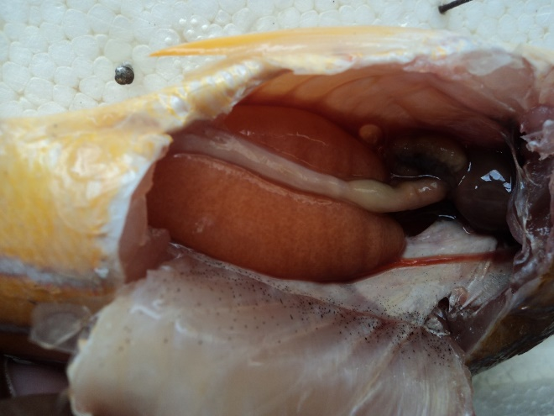

**Figure 9:** Lab analysis: dissection of the fish (*Lutjanus quinquelineatus)*

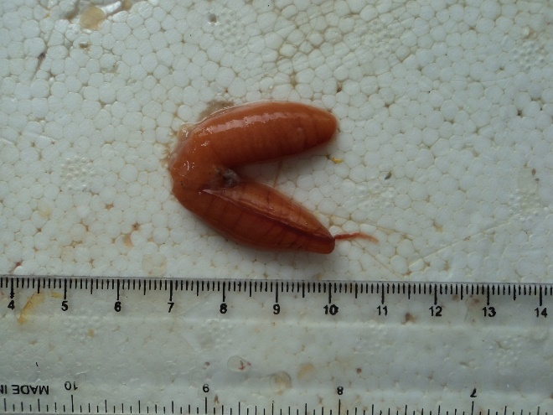

**Figure 10:** Lab analysis: gonads of the fish (*Lutjanus quinquelineatus)*

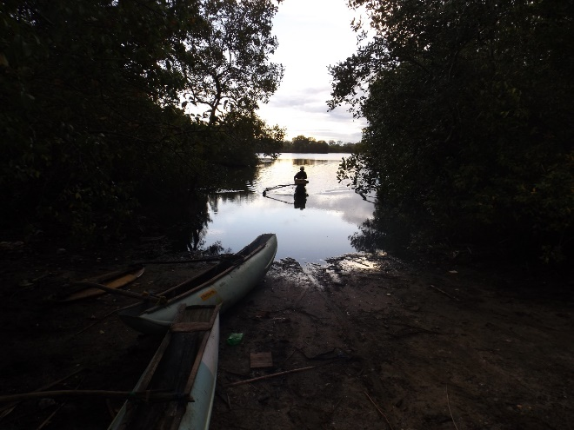

**Figure 11:** Panama Lagoon

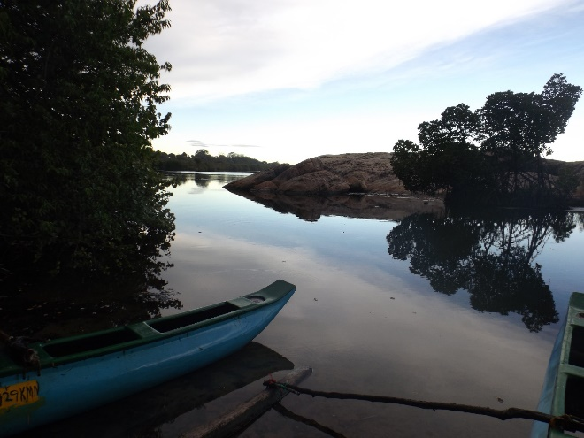

**Figure 12:** Panama Lagoon

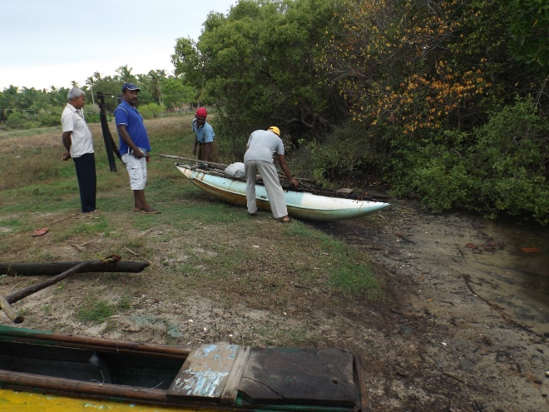

**Figure 13:** Data collection at the field at Panama Lagoon

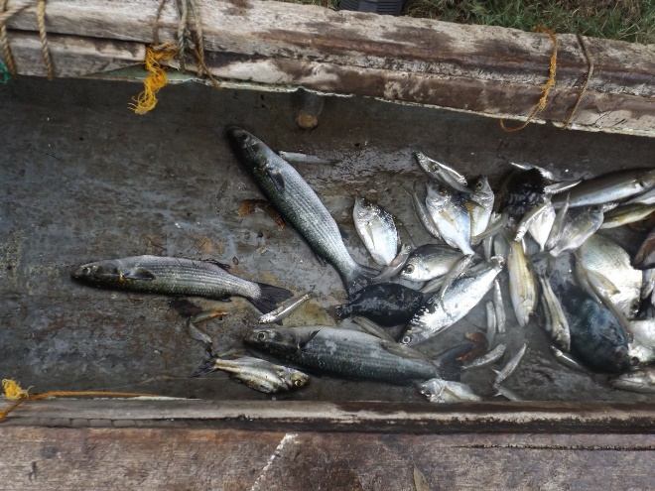

**Figure 14:** Fish catch of a fisherman at Panama Lagoon