Water Quality and Heavy Metal Monitoring in Water, Sediments, and Tissues of Grey Mullet (Mugil cephalus) from the Negombo Estuary in Sri Lanka.
B.R.C Mendis¹, M.M.M Najim² and H.M.P Kithsiri¹

Abstract
Water quality and heavy metals of the water, sediments and fish tissues of the Negombo estuary were investigated in the one year study period from January 2014. The objectives of this study were to assess the levels of the water quality and heavy metal of the water, sediments and edible fish tissues. Sixteen sampling locations were selected along the north, south, west and east regions. The pH fluctuated between 6.7 to 7.82, Electrical Conductivity of varied from 13.9 to 29.6 ms/cm, Chemical Oxygen Demand varied from 133.0 to 469.0 mg/l and BOD was observed the range from 20.7 to 24.8 mg/L. These recorded COD and BOD levels above the permissible limits in water.
The results of this study indicated that the concentration of the metals in water Pb, Cd, and Hg high level in the north region. Significant differences (p<0.05) were observed for all metals in water. The sediments concentration (mg/kg) were Pb 3.1 to 7.9; Cd, 0.4 to 1.06; Hg 0 to 0.001; Cu, 0.025 to 0.042; Cr, 9.55 to 14.3 and Fe, 388.0 to 778.6 respectively. The sediment metals of Pb and Hg content varied significantly (p<0.05) depending for all sites. The concentrations (mg/kg) of metals in the fish tissues were Pb,0 to 0.5; Cd, 0.3 to1.1; Hg, 0.0005 to 0.05; Zn, 31.4 to 119.2; Cu,2.35 to 4.6; Cr, 3.9 to 5.22 and Fe, 26.4 to 32.8 respectively. Significant differences (p<0.05) were observed for Pb and Hg depending on fish tissues.

Key Words: Water Quality, Heavy Metals, Sediment, Fish Tissue

_________________________
¹ PhD candidate, Faculty of Graduate Studies, University of Colombo, Colombo 03, chani004@yahoo.com
² Professor, Environmental Conservation and Management, Department of Zoology and Environmental Management, Faculty of Science, University of Kelaniya, Kelaniya, najimhn@yahoo.com
¹ Deputy Director General (R&D) National Aquatic Resources Research and Development Agency, Colombo 15, Sri Lanka, palihikkaduwa@gmail.com

Introduction
Negombo estuary is becoming polluted due to rapid industrialization and urbanization in the area (Silva, 1996). Anthropogenic activities continuously increase the amount of heavy metals in the environment, especially in aquatic ecosystem, which is growing at an alarming rate and has become an important worldwide problem (Malik, et al., 2010). Increase in population, urbanization, industrialization and agricultural practices have further aggravated the situation (Giguere, et al., 2004; Gupta, et al., 2009). As heavy metals cannot be degraded, they are deposited, assimilated or incorporated in water, sediments and aquatic animals and thus (Linnik and Zubenko,2000) causing heavy metals pollution in water bodies (Al-Khafaji,2010). Water pollution is thus a cosmopolitan problem that needs urgent attention and prevention (Ali, et al., 1996). It resulted from many sources, e.g. accidental spillage of chemical wastes, discharge of industrial or sewerage effluents, agricultural drainage, domestic wastewater and gasoline from fishery boots (Handy, 1994). Water pollution is one of the principal environmental and public health problems in Negombo estuary in Sri Lanka (Silva, 1996). During its two fresh water canals through, the estuary receives numerous non point and point source discharges. Now the changes in a water quality are primarily due to a combination of contaminants of anthropogenic activities. Water quality is a term used to express the suitability of water to sustain various uses (Fernandez, et al., 2002). Some of these effects are the polluting activities, such as the discharge of domestic, industrial, urban and other wastewater into the watercourse. However, monitoring has also evolved to determine trends in the quality of the aquatic environment and how the environment is affected by the release of contaminants, by other human activities. Sediments are one of the possible media in aquatic monitoring. Apart from water, sediments are also responsible of nutrients and pollutant transportation in aquatic environment (McCready, et al., 2006). Sediments are known to capture hydrophobic chemicals pollutants entering water bodies and slowly releasing the contaminant back into the water column. Therefore, ensuring a good sediment quality is crucial to maintain a healthy aquatic ecosystem, which ensuring good protection of human health and aquatic life (Goodwin, 2003). Fish accumulate toxic chemicals directly from the water and through their diet, and contaminant residues may ultimately reach concentrations hundreds or thousands of times above those measured in the water, sediment and fish. For this reason, monitoring fish tissue contamination serves an important function as an early warning indicator of sediment contamination or related water quality problems (Osman, et al., 2007). Monitoring of fish tissue contamination also enables us to detect concentrations of toxic chemicals in fish that may be harmful to consumers, and take appropriate action to protect public health and the environment. A combination of bioaccumulation and measurements of water and sediment quality can provide a good indication of conditions and potential risks to the water body. The present study was aimed to study the heavy metal monitoring in water, sediments, and tissues of the mullet species (Mugil Cephalus) along the whole course of the Negombo estuary. Heavy metals such as copper and zinc are essential for life whereas some metal including mercury, lead and cadmium are biologically non essential which can be toxic to biota at very low levels. High concentration of some essential trace metals may become toxic at concentration which exceeds the required limits (Wright and Welbourn 2002). The objectives of this study were to assess the levels of the water quality and heavy metal of the water, sediments and edible fish tissues.

Research Methodology
Study site
Negombo estuary is a shallow basin estuary of approximately 3,164 ha in extent, located between latitude 7’- 7°12’ N and longitude 79°-79°53’ E in the West coast of Sri Lanka. It is connected to the sea by a single narrow opening, the Negombo channel segment at its northern end, which is open year round. The Negombo estuary extends 12 km in length, 3.75 km at its widest point (Jayakody, 1994). It has a surface area of 35 km² and holds about 22.5 million m³ of water (Hettiarachchi and Samarawickrama, 2003).

Sampling sites for analyzing water quality were selected for covering the entire estuary based on the channels and pollutant inputs from industrial, tourism, agriculture and municipal sources. The sixteen sampling sites were selected the locations at which the channels are entering into the estuary (Figure 1).These sampling locations included the points in the estuary, effluent inlets from most of the industries at Ja-ela and Katunayeke free trade zones, boat anchoring locations and wastewater discharge points from houses. This study was initiated with the objectives of monitoring the surface water quality and identifying the possible pollutants sources, based on a comprehensive literature review and field visits to the relative sites. This study focused on the surface water quality, and heavy metal levels in water, sediment and fish tissues in the estuary, with a view of assisting the identification of environmental conditions under increasing anthropogenic influences, especially from industrial, municipal, agricultural and tourism sources (Table 1). This study is mainly focused on physico chemical parameters of water including pH, Electrical Conductivity, Total Suspended Solids, Chemical Oxygen Demand, Biochemical Oxygen Demand, Ammoniacal Nitrogen, Nitrate Nitrogen, and Heavy metals levels Lead (Pb), Cadmium (Cd), Mercury (Hg) Copper (Cu), Zinc (Zn), Chromium (Cr), and Iron (Fe) in water, sediment and selected edible fish tissues. Sampling sites are categorized as North, South, East, and West estuary (See Table 1).
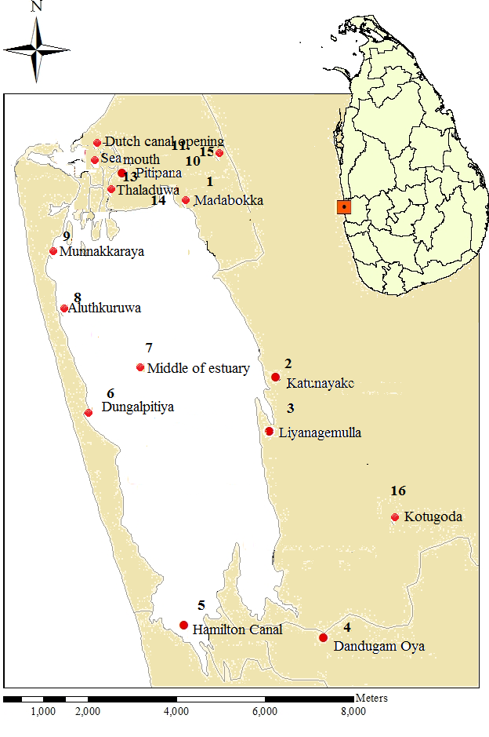
Figure 1: Sampling Locations at Negombo Estuary

Table 1: Description of Study Sites at Negombo Estuary

Sampling Locations | Section of the estuary | Input sources (if any)
Location 1, 9, 10, 11, 12, 13, 14, 15 | Northern Estuary  Site 1 | Municipal solid waste, industrial effluents, animal livestock urbanization, hotels, fishing harbor and boat repair stations and domestic sewage outlets.
Location 4, 5, | Southern Estuary  Site 2 | Two fresh water canals, Ekala industrial zone, seaplane landing site, various effluents in Hamilton canal outlet.
Location 6, 8 | Western Estuary  Site 3 | Hotels, shrimp farm and fish processing industries.
Location 2, 3 | Eastern Estuary  Site 4 | Katunayake industrial processing zone, hotels and housing scheme.
Location 7, 16 | Reference Point  Site 5 | Ekala Industrial zone (near 01 km distance)

Analysis of water
Water sample were collected monthly by selected sixteen sampling locations, along the estuary during the one year period from January 2014 to December 2014. Water samples were kept into polyethylene bottle in ice and transportation to analyze in the laboratory. Some of the physico chemical insitu parameters including the Electrical Conductivity and pH measured by using portable meters. The exsitu parameters as Chemical Oxygen Demand, Total Suspended Solids, Biochemical Oxygen Demand, Ammoniacal Nitrogen, and Nitrate Nitrogen, were measured according to the Standard Methods for Examination of Water and Wastewater (20st Edition, APHA Standard Methods). Heavy metals in water, sediments and fish tissues Pb, Cu, Cr, Zn, Hg, Fe and Cd were measured by Atomic Absorption Spectrophotometer.

Analysis of Sediment
Sediment samples from the selected sites were collected monthly interval from the same sample sites of the estuary during the one year period from January 2014 to December 2014. These were collected by using PVC pipe and kept frozen until analyzed. Sediment samples were allowed to defrost and then air dried in a circulating oven at 30°C and sieved mechanically using a 02 mm sieve. For the digestion of samples, one gram (01g) sieved sediment was digested with repeated addition of nitric acid and 30% hydrogen peroxide. For Atomic Absorption Spectrometry analysis, the resultant digest was reduced in volume and then diluted to a final volume of 100 ml. The elements of concern (Fe, Zn, Cu, Pb, Hg, Cr and Cd) in the samples were determined by Atomic Absorption Spectrophotometer.

Analysis of fish tissues
Fresh fish samples (Mugil cephalus) were collected by using cast nets from the same sampling sites during the one year period from January 2014 to December 2014. These tissues were washed with tap water followed by distilled water, then oven dried to constant weight at 105 ⁰C. The dried fish was crushed and powdered in an agate mortar, then, they were kept in polyethylene bottles for analysis. One gram (01g) portions of fish tissues were digested by means of a microwave digestion after addition of nitric acid and hydrogen peroxide. The results were calculated in milligram per kilogram wet weight (mg/kg wet wt). Pb, Cd, Hg, Cu, Zn, Cr and Fe were tested using AOAC (2002). Hg in the digested fish sample was analyzed using cold vapor Atomic Absorption Spectrophotometer.
Data analysis
Differences in the level of each metal in water, sediment and fish tissue from the estuary were tested by one way analysis of variance (ANOVA). Where differences were significant, mean values were compared by Turkey’s test. The significance level was tested at the p<0.05.

Results
Water analysis
The results of mean values of the studied physical chemical parameters are given in table 2 for water quality parameters in the selected sixteen sampling locations (summaries to 5 sites - see Table 1).

Table 2: Mean Values of Different Water Quality Parameters

 | pH | EC (ms/cm) | BOD  (mg/l) | Nitrate N  (mg/l) | Ammonia  (mg/l) | COD  (mg/l) | TSS  (mg/l)
Site-1 | 7.82 | 29.6 | 24.8 | 0.711 | 0.14 | 469.0 | 24.9
Site-2 | 6.70 | 13.9 | 22.8 | 1.08 | 0.20 | 161.5 | 11.2
Site-3 | 7.60 | 24.5 | 23.5 | 0.66 | 0.09 | 361.1 | 29.2
Site-4 | 7.45 | 20.0 | 21.9 | 0.90 | 0.135 | 133.0 | 13.5
Site-5 | 7.45 | 22.1 | 20.7 | 0.95 | 0.215 | 229.7 | 18.0

The pH measurement is one of the most important and frequently used tests in water chemistry (APHA, 1998). The pH of surface water fluctuated between 6.7 to 7.82 respectively. The results of indicated that high pH value recorded in site 1(see Table 2). It was well within the standard limits (CEA 1994). Electrical Conductivity of surface water varied 13.9 to 29.6 ms/cm during the study period. The EC values also increased from site 1 and the lowest at site 2 (See Table 2).

Biochemical Oxygen Demand depends on temperature, extent of biochemical activities, concentration of organic matter and such other related factors. During the study period, BOD was observed to be in the range from 20.7 to 24.8 mg/L. Maximum value of BOD was recorded at site 1 and the minimum was observed at site 5. So the observed BOD value was 10 mg/L, which is within the permissible limit (CEA, 1994).
Nitrate and Ammonia are the most common forms of nitrogen in aquatic systems. The high value nitrate was recorded in site 2 ((See Table 2). Ammonia concentration in all sites showed low levels during the whole period of investigation.
The Chemical Oxygen Demand (COD) is used as a measure of oxygen equivalent of the organic matter content of a sample that is susceptible to oxidation by strong chemical oxidants. The COD levels shown that Table 2,increase from site 1. This may be due to the discharge of industrial effluents into the estuary by some untreated effluents release by factories in these areas, in addition to the discharge of municipal wastewater and other wastes into the estuary.
Total Suspended Solid (TSS) shown that Figure 8 an increase from site 3. Because of the variations are shown that hotels, shrimp farm and fish processing industries waste inputs are discharge to the estuary.
Metal levels in water
The levels of seven metals in water at sixteen sampling location (summaries to see table 1) of the estuary are presented in Table 3.

Table 3: The Mean Value of Selected Metals in Water at Sampling Site

 | Pb | Cd | Zn | Cu | Cr | Fe | Hg
Site 1 | 0.026 | 0.015 | 0.360 | 0.03 | 0.039 | 0.462 | 0.013
Site 2 | 0.023 | 0.001 | 0.695 | 0.03 | 0.003 | 0.485 | 0.001
Site 3 | 0.005 | 0.0 | 0.165 | 0.035 | 0.055 | 0.335 | 0.004
Site 4 | 0.017 | 0.001 | 0.021 | 0.025 | 0.007 | 0.480 | 0.0
Site 5 | 0.01 | 0.0005 | 0.290 | 0.022 | 0.023 | 0.445 | 0.0

The concentration (ppm) of the metals in water showed a lead (Pb) values were fluctuated within a narrow range 0.01 to 0.005 ppm respectively. The high Pb values were recorded in the site 1 (See Table 3). The Cd exhibited a wide range of variation between 0.0 to 0.01 ppm. The highest value was recorded at site 1 (See Table 3). Zinc concentrations fluctuated between 0.029 to 0.69 ppm and Copper concentration ranged from 0.02 to 0.03 ppm (See Table 3).

The high concentration of Cr was recorded site 3 low one was recorded at site 2 (see Table 3).Hg seems to be very rare in the estuary water and it was recorded only in some sites along the estuary. Generally the increase in heavy metal concentrations in the estuary water might be attributed to the direct inputs from different sources (industrial wastes).

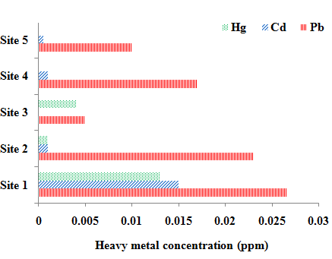

Figure 2: Comparison of non essential metals in water Hg, Cd and Pb Concentration vs Sites

The sampling sites 1 were located in the north region of the estuary whereas the sites 2,3 and 4 were located in the south, west and east region (See Table 1).The result indicate that the levels of non essential (toxic) heavy metals as Pb, Cd and Hg in water were comparatively high in north region of the estuary (See Figure 2).The limit of detection of water in Lead, Copper, Cadmium, Mercury, Zinc, Iron and Chromium contents in water were below the standard limits defined for each element are 0.5 mg/l, 0.5 mg/l, 0.2 mg/l, 10 mg/l, 40 mg/l, 20 mg/l and 10 mg/l respectively (EU,2002).

Sediments analysis
Results of heavy metal analysis of sediments existing at the bottom of the water column plays a major role in the pollution of the heavy metals. Low level discharge of a contaminant may meet the water quality criteria, but long term partitioning to the sediments could result in the accumulation of high loads of pollutants. Therefore the determination of heavy metals in the sediments is fundamental to realize the toxic pollutants in the estuary sediment. The levels of selected metals in sediments at sixteen sampling location summaries to sites of Negombo estuary (See Table 4).

Table 4: The Mean Values of Selected Metals in Sediment at Sampling Site

 | Pb | Cd | Hg | Zn | Cu | Cr | Fe
Site 1 | 3.88 | 1.06 | 0.001 | 142.6 | 0.033 | 11.40 | 523.5
Site 2 | 5.90 | 0.45 | 0.001 | 152.5 | 0.025 | 9.55 | 778.6
Site 3 | 3.10 | 0.40 | 0.0 | 154.25 | 0.042 | 13.15 | 538.5
Site 4 | 7.95 | 0.40 | 0.0 | 50.75 | 0.025 | 14.30 | 437.5
Site 5 | 4.05 | 0.45 | 0.0 | 1.50 | 0.025 | 9.85 | 388.0

The ranges of the concentration (mg/kg) of all metals in sediments were Pb 3.1 to 7.9; Cd, 0.4 to 1.06; Hg 0 to 0.001; Cu, 0.025 to 0.042 ; Cr 9.55 to 14.3 ; Cr, 9.55 to 14.3 and Fe, 388.0 to 778.6 respectively. The highest level of Pb in sediments was found in site 4 (See Table 4). The highest level of Cd and Hg were in the sediment was found at the sampling site 1 (See Table 4) located in the north region. Whereas levels of Cr was high in the site 4 located in the west region. Cu and Fe levels were the highest in the sediments from site 3 and site 2 sediments collected from south and west region respectively.

Hg was recorded in not detected levels in site 3, 4 and 5 (See Table 4). Site 1 and Site 2 concentrations seem to be constant level. The wide ranges of metal concentrations which recorded for some heavy metals may be attributed to variations in mud percent and increase in heavy metals rich urban effluents draining into estuary.
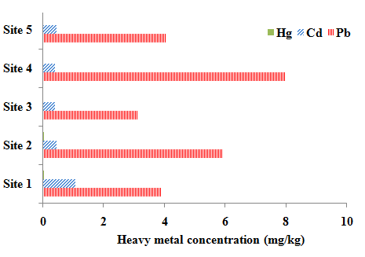

Figure3: Comparison of non essential sediment metals in Hg, Cd and Pb Concentration vs Sites

For sediment from Negombo estuary the non essential metal concentration decrease in the order Pb>Cd>Hg (See Figure 2).

Metal levels in Fish
Total metal levels in tissue of the fish (Mugil cephalus) are presented in sixteen sampling location summaries to site of the estuary are presented in Table 5.Show the mean values of the tested heavy metals in Mugil cephalus fish tissues. Knowledge of heavy metal concentrations in fish is important with respect to human consumption of fish. In the estuary, fish are often at the top of the food chain and have the tendency to concentrate heavy metals from water.
Table 5: The Mean Values of Selected Metals in Fish Tissue at Sampling Site

 | Pb | Cd | Hg | Zn | Cu | Cr | Fe
Site 1 | 0.157 | 1.045 | 0.03 | 51.43 | 4.32 | 4.27 | 31.08
Site 2 | 0.30 | 0.45 | 0.0005 | 119.2 | 4.04 | 4.33 | 32.8
Site 3 | 0.25 | 0.55 | 0.001 | 31.4 | 3.24 | 5.22 | 26.49
Site 4 | 0.0 | 0.35 | 0.05 | 37.2 | 2.35 | 4.73 | 32.29
Site 5 | 0.50 | 1.10 | 0.01 | 52.18 | 4.60 | 3.90 | 32.84

The concentrations of metals in the edible muscle tissues were Pb,0 to 0.5; Cd, 0.3 to 1.1; Hg, 0.0005 to 0.05; Zn, 31.4 to 119.2; Cu,2.35 to 4.6; Cr, 3.9 to 5.22 and Fe, 26.4 to 32.8 mg/kg. The highest level of Pb, Cd and Cu were in the fish tissue were found at the sampling site 5. Whereas levels of Cr was high in the site 3 located in the west region. Zn and Fe levels were the highest in site 5 (See Table 5).
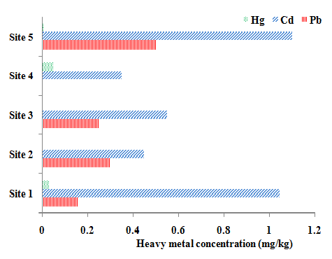

Figure 30: Comparison of non essential metals in fish tissues in Hg, Cd and Pb Concentration vs Sites
The detected mercury, copper, zinc, cadmium, lead and iron contents in fish tissue were below the standard limits defined for each element < 0.05 mg/kg, <10 mg/kg, <40 mg/kg, 0.5 mg/kg, <0.5 mg/kg, <0.5 mg/kg and <40 mg/kg respectively (FAO, 1983).

Discussion
Environmental quality guidelines heavy metal concentrations in fish are important with respect to nature of management and human consumption of fish. In the estuary, fish are often at the top of the food chain and have the tendency to concentrate heavy metals from water. Metals uptake and their toxicity in aquatic fauna are influenced by many factors such as Chemical Oxygen Demand, Biochemical Oxygen Demand and Nutrients levels in water. Copper can combine with other contaminants such as ammonia, mercury and zinc to produce an additive toxic effect on fish. Urbanization and sewage disposal are major source of zinc pollution. Lead is non essential element and higher concentrations can occur in aquatic organisms close to anthropogenic sources. It is toxic even at low concentrations and has no known function in biochemical processes (Handy, 1994). Water quality of Negombo estuary is influenced by several inland water sheds (Dandugam oya and Hamilton canal) and the sea. The fresh water canals and the tidal floods may transport toxic pollutants originating in different parts of the catchments, land use or in the estuary (Indrajith, et al., 2008). The estuary is susceptible to chemical pollution due to ongoing development activities of Negombo and Katunayake areas (CEA, 1994). Estuary water is not utilized for human consumption because of the salty nature. Metal levels of water and sediment directly relate to the aquatic life of the estuary. The present study provides primary data with respect to the seven metals Pb, Cu, Cr, Zn, Hg, Fe and Cd in water, sediment and fish tissue of the Negombo estuary.

In the present study revealed that levels of heavy metal variations exist in different regions of the estuary, with respect to the dissolved Pb, Cu, Cr, Zn, Hg, Fe and Cd. The levels of Pb, Cd and Hg in water collected from some sampling sites located in the site 1 in other region were higher compared to the other sites. North region of the estuary is being polluted due to the various anthropogenic activities such as solid waste from industries, slaughter houses, boat yards and animal farms. High levels of Pb in water samples collected from site 1 in comparison to other sampling sites may be partly due to the discharge of fuel from motor boat to the estuary water. North part of the estuary is connected to the sea mouth and mixing to sea water, through the levels of Pb, Cd and Hg in water in all sampling sites in this part were higher than other sites. The levels of sediment Pb north region were comparatively low. The status of the sediment of this area is affected by tidal waves, sedimentation and human activities. Hence the level of metals in the sediments of north region to change throughout the year and this may have partly contributed to low Pb accumulation in sediment of this area in comparison to the other sites.

The sampling site 2 receives water mainly from the Hamilton canal and Dandugam oya and they carry various effluents from Ekala industrial zone (CEA, 1994). In comparison to the Site 1 of the estuary the levels of metals in water (Pb, Hg, and Cd) were high but levels of metals in sediments (Pb, Hg, and Cd) were higher in sampling sites 4, receives waste from hotels, shrimp farm and fish processing industries. Generally the levels of Pb, Cd and Hg in water of this area were low. West region sampling sites 3 receives waste from hotels, shrimp farm and fish processing industries. Generally the levels of Pb, Cd, Zn and Fe in water of this area were low but the levels of sediment bound metal were comparatively high. East region site 4 receives effluent from Katunayake industrial processing zone, hotel and housing scheme. Hence the levels of metals in water Pb, Cd and Fe were high in this region.

Cadmium is highly toxic non essential heavy metal and it does not have a role in biological processes in living organisms. Thus even in low concentration, Cadmium could be harmful to fishes. The increase of iron accumulation in fish tissue in this study may be related to the increase of total dissolved iron in water and consequently increase the free metal iron concentration and there by lead to an increase in metal uptake by different tissues. Results of heavy metal analyses in water, sediment and fish tissues indicated that were relatively metal contamination problems in Negombo estuary is being polluted due to various anthropogenic activities.

Conclusions
The results for the most parameters indicate that, the Bio chemical Oxygen Demand, Chemical Oxygen Demand and Total Suspended Solids, are highest in site 1 (Northern region) of the estuary. Hence, the main reason for the above results was highest values indicated the discharge of sewage and dumping of solid waste from households and other anthropogenic activities and accelerating sedimentation. Large amounts of wastewater containing organic pollutants & various processes of chemicals release to this site. It drains water carrying nutrients and organic matter from the heavily populated catchment area and has faced the threat of the degradation of water and sediment quality. The results of the present study will be helpful for developing future management plans for sustainable utilization of this brackish water ecosystem. Investigation reports were prepared by giving recommendations to avoid or overcome such incidents in future.
References
Ali., M., and Soltan., M. (1996). The Impact of Three Industrial Effluents on Submerged Aquatic Plants in the River Nile, Egypt, Hydrobiologia, Vol. 340, No. 1-3, pp. 77- 83.

Al-Khafaji, B.Y. (2010): Distribution pattern of selected heavy metals in water, sediments and two species of fish from Al-Hammar Marsh south of Iraq. The 5th Scientific Conference 2011-Collegeof Science- Babylon Univ., 5:115-124.

American Public Health Association (1998). Standard methods for the Examination of water and
Wastewater 20th edition, Published by American Water Works Association Washington DC
20005.

AOAC, (2002). The Association of Official Analytical Chemists. Official Methods of Analysis. 15th ed. Atomic Absorption Method for Fish”. Washington, D.C.

CEA, (1994). Muthurajawela marsh and Negombo Lagoon wetland conservation plan. Central Environmental Authority, Sri Lanka.

EU, (2002). The Commission of the European Communities , Commission regulation, (EC) No 221/2002 amending regulation (EC) No. 466/2001 setting maximum levels for certain contaminants in food stuff in order to protect public health ,Official Journal of the European Communities 7.2 2002, 1,37/5-1,37/6.

FAO, (1983). Compilation of Legal Limits for Hazardous Substances in Fish and Fishery Products. Available from: http://www.fao.org/docrep/014/q5114e/q5114e.pdf (28th May 2013).

Fernandez, G., G. M. Chescheir, Skaggs., R. W. and Amatya., D. M. WATGIS: A GIS-Based Lumped Parameter Water Quality Model, Transactions of the ASAE, Vol. 45, No. 3, 2002, pp. 593- 600.

Giguere, A.; Campbell, P.G.C.; Hare, L.; McDonald, D.G.; Rasmussen, J.B. (2004): Influence of Lake chemistry and fish age on cadmium, copper and zinc concentrations in various organs of indigenous yellow perch (Perca flavescens). Cand. J. Fish. Aquat. Sci. 61:702-716.

Goodwin. T. H. Young., A., Holmes, M., Old, G., Hewitt, N., Leeks., G. and B. Smith., B., “The
Temporal and Spatial Variability of Sediment Transport and Yields within the Bradford Beck
Catchment, West Yorkshire,” Science of the Total Environment, Vol. 314, 2003, pp. 475- 494.

Gupta A.; Rai, D.K., Pandey; R. S., Sharma, B. (2009): Analysis of some heavy metals in the riverine water, sediment and fish from river Ganges at Allahabad. Environ. Monit. Assess. 157: 449-458.

Handy, R. (1994). Intermittent Exposure to Aquatic Pollutants Assessment, Toxicity and Sub
lethal Responses in Fish and Invertebrates,” Comparative Biochemistry and Physiology C
Pharmacology Toxicology & Endocrinology, Vol. 107, No. 2, 1994, pp. 171-184.

Hettiarachchi, S.S.L. and Samarawickrama, S.P., (2003). Towards Improved Environmental
Management of the Negombo Lagoon. COPEDEC VI, Colombo, Sri Lanka

Indrajith, H.A.P, Pathirane, K.A.S & Pathirane, A., (2008). Heavy metal levels in two food fish species from Negombo estuary, Sri Lanka; Relationships with the body size Sri Lanka J. Aquat. S Dci.13 (2008): 63-81.To assess the levels of heavy metal in two fish species relationships with the body size.

Jayakody, D. S., (1994). Traditional lagoon fisheries in Negombo. In: Development of Community
based Fishery Management.
Linnik, P.M. & Zubenko, I.B. (2000): Role of bottom sediments in the secondary pollution of Aquatic environments by heavy metal compounds. Lakes and Reservoirs: Res. & Mang., 5: 11 Malik, N.; Biswas, AK.; Qureeshi, Ta.; Borana, K. and Virha, R. (2010): Bioaccumulation of heavy metals in fish tissues of a freshwater lake of Bhopal. Environ. Monit. Assess. 160: 267- 276.

Mc Cready, S., Birch G. F. and Long, E. R.(2006).“Metallic and Organic Contaminants in Sediments
of Sydney Harbor, Australia and Vicinity - A Chemical Dataset for Evaluating Sediment Quality
Guidelines, “Environment International, Vol. 32, No. 4, 2006, pp. 455-465.

Osman, A., Wuertz, S., Mekkawy, I., and Kirschbaum., F. “Lead Induced Malformations in Embryos
of the African Catfish Clarias Gariepinus (Burchell, 1822),”Environmental Toxicology, Vol.22, No. 4,
2007, pp. 375- 389.

Papa filippaki.,A. K, Kotti , M. E and Stavroulakis, G. G. (2008). Seasonal variations in dissolved heavy metals in the Keritis River, Greece. Global NEST J. 10(3): 320-325p.

Silva, E.I.(1996). Water Quality of Sri Lanka. A Review of Twelve Water Bodies Institute of Fundamental Studies, Kandy, Sri Lanka.

Wang, C. Z. Sun, J. and Wang.,F. (2011). Study on heavy metal concentrations in river sediment through the total amount evaluation method. J. Zhejiang Univ.-Sci. A(Appl. Phys. And Eng.), 12 (5):
399-404p.

Wrigh, D. A and P.Welbourn (2002). Environmental Toxicology, Cambridge press, Cambridge.

