Research Findings of the Environmental Studies Division – 2018
Theme: Aquatic Resource Management and Conservation

Project No: 5.1.1
Genotoxicity screening of drinking water wells located in the North Central Province (NCP) of Sri Lanka using plant and fish based bioassays (Continuous Project).
Objectives
- To evaluate potential toxicity of drinking water wells located in the Medawachchiya area using combination of physico- chemical analysis and bioassays.
- To assess heavy metals/metaloids in the liver, kidney and muscle tissues of two selected edible fishes.

Research Findings
Plant and fish bioassays
- Results of the plant bioassay indicated potential toxicity associated with water in the dug wells used by CKDu affected families based on A. cepa root growth retardation and mitotic index depression effects and induction of chromosomal and nuclear aberrations compared to the negative controls and to the reference dug wells in some cases (P < 0.05).
- Fish bioassay showed potential toxicity associated with water in the dug wells used by CKDu affected families based on cell apoptosis in the peripheral blood and blebbed nuclei in the erythrocytes and cell apoptosis of head kidneys of the fishes exposed to water from several dug wells used by CKDu affected families compared to negative controls (P < 0.05).
- The water samples collected from some reference wells also showed apoptosis of peripheral blood erythrocytes compared to negative controls (P < 0.05).

Heavy metals/metaloids in Fish

- Arsenic levels in the muscle tissues of all Nile tilapia and butter catfish were below the limit of detection (<0.05 mg/kg).
- Muscle tissues of only five fish sampled in whole sampling(Only during the third sampling event) contained cadmium in the range of 0.05-0.10 mg/kg and Cd levels of only one Tilapia fish exceed the Standard limit 0.05 mg/kg [EU, 2006].
- Bioaccumulation pattern of cadmium in the tissues of Nile tilapia and Butter cat fish from Padaviya reservoir followed the order: muscle < liver < kidney, showing greater cadmium bioaccumulative capacity in the kidney tissues.

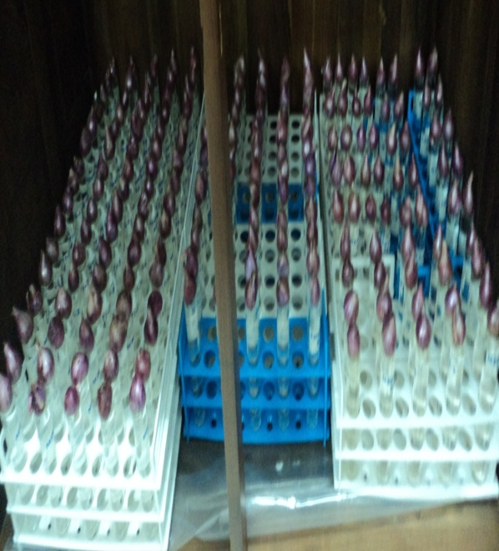  Plant Bioassay | 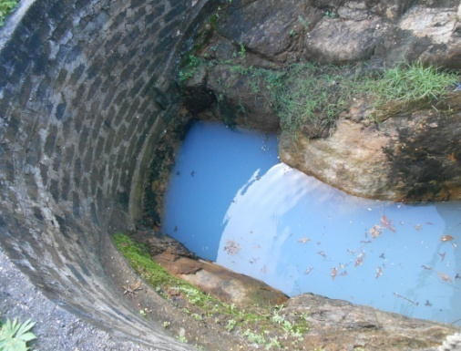  Drinking water well in the study area
Fish Bioassay | 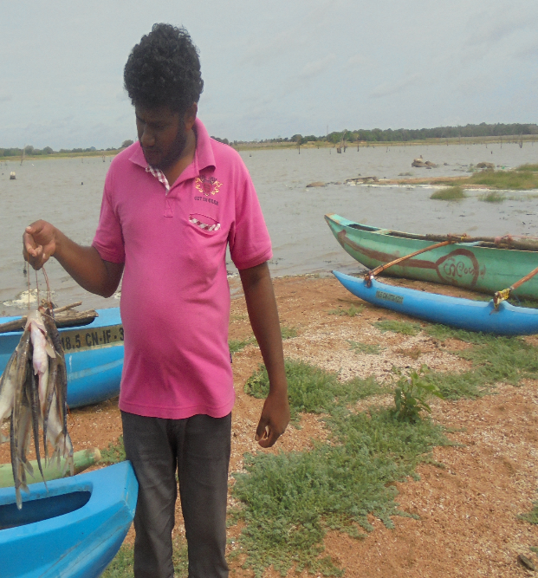  Collected fish from Padaviya Reservoir

Project No: 5.1.2
Study on Pollutant behaviour of Kelani River basin
Objectives
- To investigate the pollutant status of Kelani river and some of its tributaries
- To investigate the pesticide behaviour with organic matter in the basins
Research Findings
- Results of the study revelead that Orugodawaththa, Thotalaga and Kolonnawa locations were highly polluted when comparing to the other sampling locations examined in the Kalani river basin.
- Mean concentration values received for ammonia-N and dissolved phosphate for the Orugodawatta, Thotalanga and Kollonnawa locations are as 4.17 ± 0.71 , 3.12 ± 0.22 , 1.12 ± 0.6 ; and 0.25 ± 0.17 , 0.34±0.08 , 0.10±0.05 mg/l respectively.Ammonia nitrogen in the bottom samples were observed in Maaussakele reservoir and need to be further study for sediment, sedimentation rates and existing sedimentation condition in the reservoir.
- Nallathanni and Upcot sampling locations were identified as low polluted areas
- Maskeliya Oya sampling locations were subjected to nutrient pollution when compared with other upstream sampling locations.
- Most of the sampling locations from lower basin, which are connected to industrial areas, indicated poor water quality.
- Higher amount of solid waste (plastic) observed in the Maskeliya Oya sampling location due illegal dumping of solid waste in to stream.

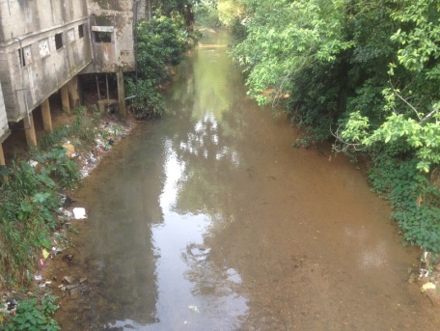 | 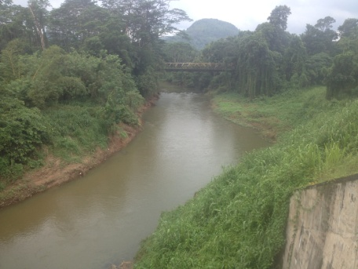
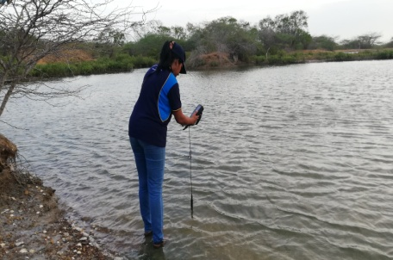 | 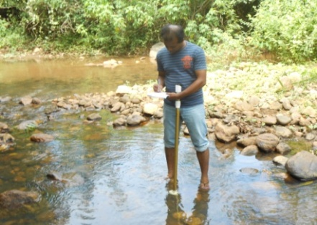
Some of the study sites
Project No: 5.1.3
Investigation of causes for emergency incidents such as oil spills, algal blooms and fish kills (Emergency studies)
Objectives
- Identify and investigate the major causes for environmental emergencies and provide recommendations to the relevant authorities to overcome those situations.
- Within the 2018, total of four emergencies were informed to NARA to investigate.
Research Findings

MONTH | PLACE | INCIDENT | OBSERVATIONS | CONCLUSION
January | Welikada | Fish kill | All the dead fishes were identified as the Oreochromis niloticus | Low Dissolved Oxygen due to eutrophic conditions
March | Malwana | Fish kill | Many dead fish were observed | High Chemical and Biological Oxygen Demand levels due to industrial effluents
October | Bundala Lagoon | Fish kill | Many dead fish were observed | High saline water discharges to lagoon from Saltern
October | Puttlam Lagoon | Sedimentation in water quality | Reddish colour lagoon water were observed | Soil erosion due to illegal timber cutting and uprooting plants in the area

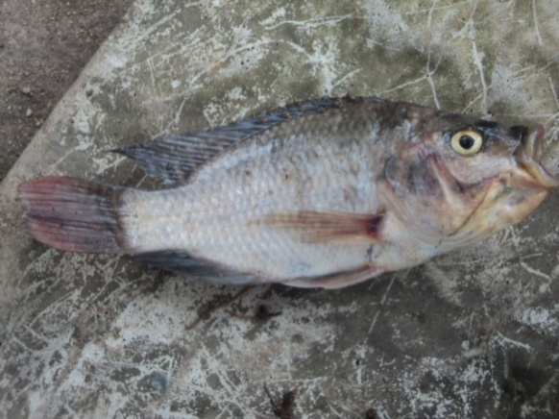 | 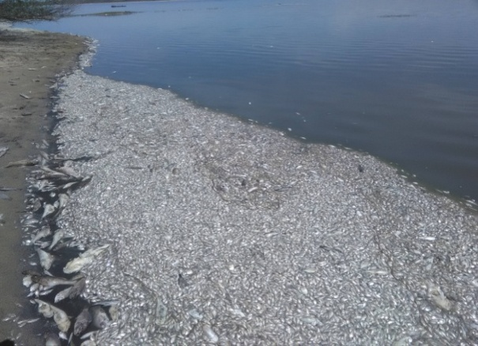
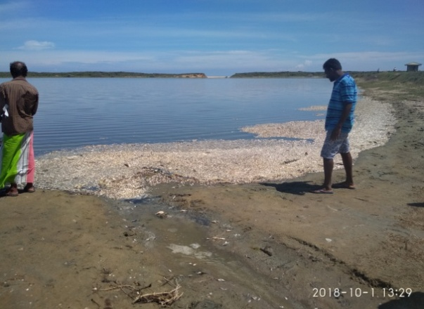 | 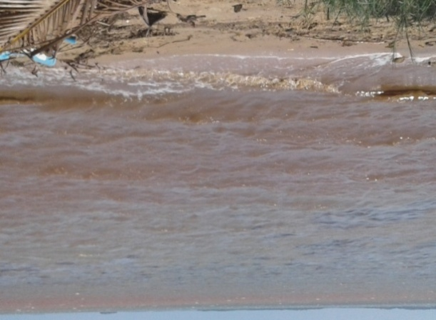
Research Highlights

Project No: 5.1.4
Assessment of current water pollution status and accumulation of heavy metals in selected edible fish species in Bolgoda Lake
Objectives
- To characterize the quality of lake water using physico-chemical methods.
- To assess associations between contaminant load and health status of the feral fish in the Lake.

Research Findings
- According to ambient water quality standards for inland waters in Sri Lanka (2001), dissolved oxygen, ammoniacal nitrogen, BOD and COD in locations Weras Ganga and near Karadiyana waste dumping site were exceed the standard limits (Standard limit : DO > 3 mg/l, BOD < 4 mg/l, COD < 15 mg/l, Total Ammonia < 0.94 mg/l).
- Arsenic (As), Chromium (Cr), Lead (Pb), Cadmium (Cd), and Mercury (Hg) metal (loid) concentrations in water were below the limit of detection (LOD: 0.05 mg/Kg).
- Copper (Cu) and Zinc (Zn) were detected in water in low concentrations which are below than their tolerance limits for discharge of effluents into inland surface waters. (Max. Tolerance Limit: Cu – 3.0, Zn – 2.0 mg/l) (Gazette notification no. 1534/18 dated 01.2.2008).
- However, relatively higher concentrations of heavy metals i.e. As, Cr, Cu, Pb and Zn were recorded in bottom sediments and fish tissues (Mystus gullio and Mugil cephalus ) than that of water.

- None of the sixteen selected USEPA PAHs were detected in water, sediment and fish tissue samples as the concentrations are below the Limits of Report (LOR) of 0.001mg/kg.

- It is observed that certain areas of the Bolgoda river and lake are illegally encroached by the urban dwellings and hotels thus, natural ecosystems are being degraded and fish breading grounds are being destroyed.

- Rapid growth of aquatic plants (Aponogeton crispus, Nymphaea, Nelumbo nucifera, Salvinia molesta, Eichhornia crassipes etc.) in Bolgoda lake was identified as a problem to fisherman and to aesthetical values of this particular Environmental Protection Area.

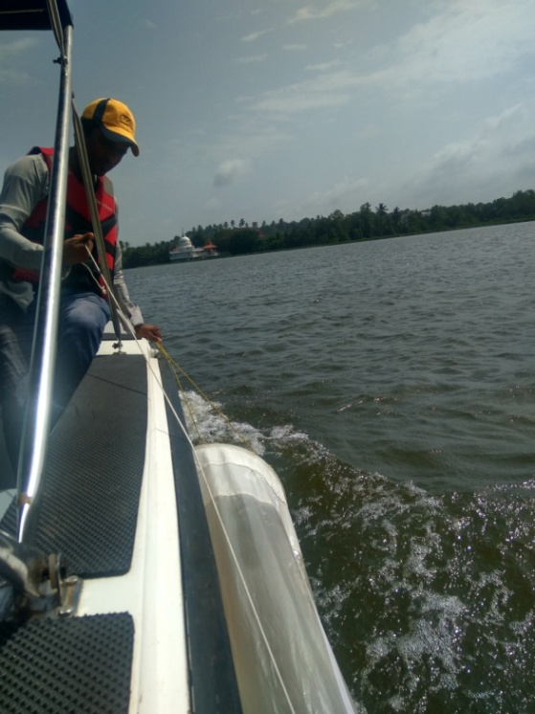 | 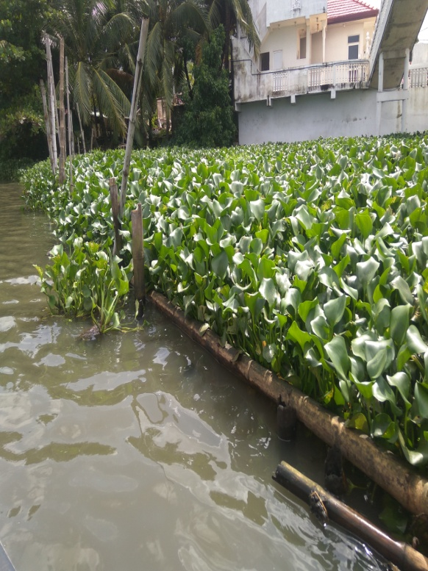
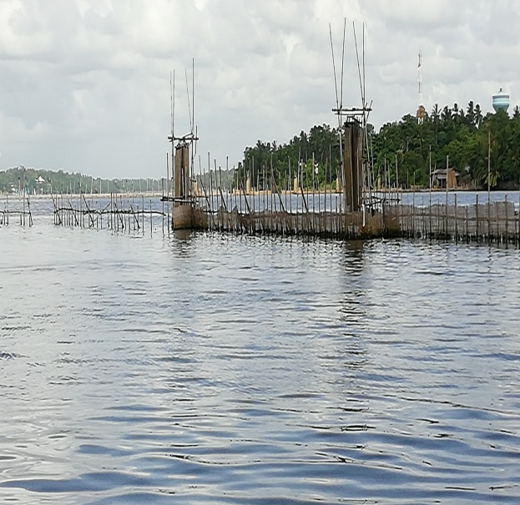
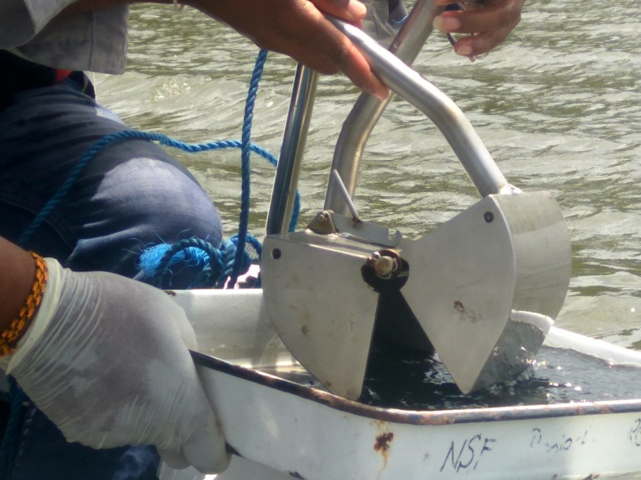
Research Highlights
Project No: 5.1.5
Assessment of Environmental Impacts of Extensive Shrimp Farming on Mundel Lake and Its Surroundings
Objectives
Component 1 -
- To determine current status of water quality and identify pollution sources to Mundel lagoon
- To identify selected indicator species in Mundel lagoon
- To recommend suitable management measures to mitigate the pollution impacts to the lagoon
Component 2 –
- To assess socio-economic impacts of semi-intensive shrimp farming to Mundel lagoon and its surrounding community.
- To identify means and ways to improve socio-economic benefits of semi-intensive shrimp farming to the farmers and community in the area

Research Findings
- Mean Ammoniacal nitrogen concentration (0.13±0.08 mg/l), Biochemical Oxygen Demand (BOD) (21-26 mg/l) and Chemical Oxygen Demand (COD) (>1600 mg/l) values in the lagoon water was indicated relatively high values .
- There is a weak or no connection between sea and lagoon through the Udappuwa lagoon mouth. Thus, reproduction of fish and shrimp is declining and hypersaline conditions (>50 ppt) recorded in dry period (February, March and April).
- The level of heavy metals i.e. Copper (Cu), Lead (Pb), Chromium (Cr), Mercury (Hg) in lagoon water was below their Limit of Quantification (LOQ) in July
- [LOQ of Copper (Cu), Lead (Pb), Chromium (Cr), Mercury (Hg) were 0.01 mg/L, 0.04 mg/L, 0.005 mg/L and 0.001 mg/L] respectively.
- The Vibrio cholera and Salmonella was not recorded in any of the tested water samples
- The Disease (IHHNV and WSSV) in shrimps were identified in shrimps farms located surrounding of the Mundel lagoon (Identification done by IARAD ,NARA ).

Social problems due to shrimp farming industry:
- Conflict between lagoon fishers and shrimp farmers due to the interruption of access ways to lagoon
- Dispute between lagoon fishers and shrimp farmers
- Shrimp farmers hire labourers to low wages from the outside of the village and it reduces the job opportunities for the villagers
- Illegal fishing in the lagoon, practiced by the outsiders coming to work in shrimp farms
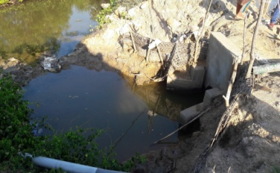  Water discharging outlets from shrimp farms | 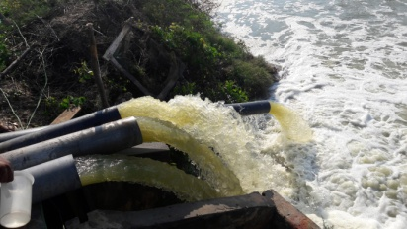  Water intakes from lagoon
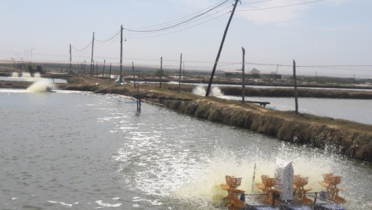
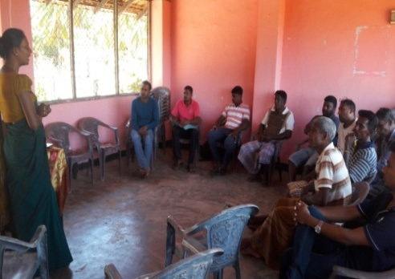
Active shrimp farms

Awareness programme to Lagoon fishermen

Project No: 5.1.6
Assessment of marine litter in the Southern and North Western Coast of Sri Lanka.

Objectives
- To Identify and classify dumping of plastic and polythene waste inputs and to give recommendations to implement conservation measures to waste management.

Research Findings
It was revealed that, marine composition of debris by material types showed that the classified by use,
- packaging material (40%) dominated the debris,
- consumer products (25%)
- fishing items (15%)
- plastic bottles (10%),
- caps/lids and food wrappers/containers 5% and 5% respectively.

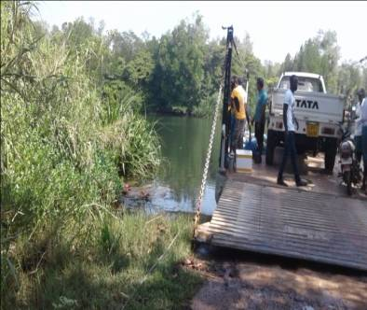  Horatota Palam Paruwa | 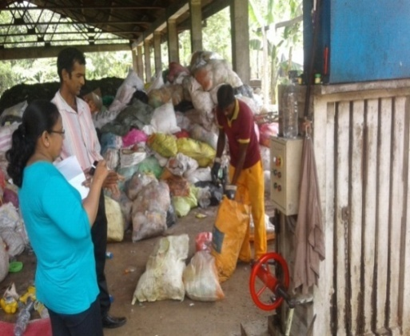  Solid waste collection site
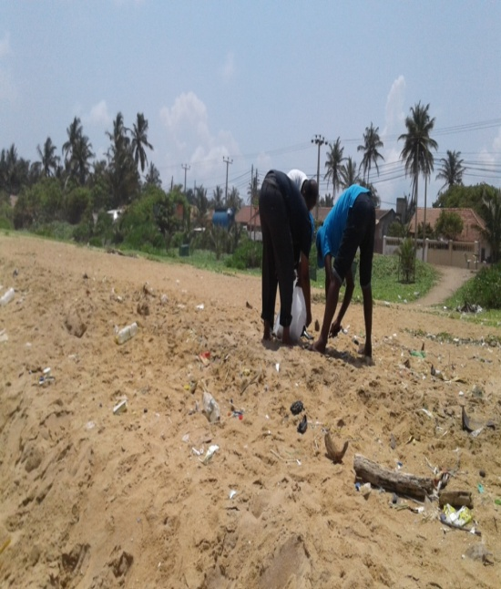  Sand Collection for analysis of micro plastics | 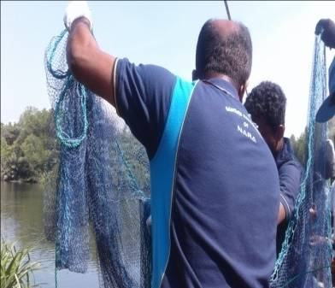  Bentota -Ithapana

