Stock structure of Amblygaster sirm (Walbaum, 1792) distributed in the coastal waters in Sri Lanka
Evaluated partial Cytochrome b (cyt-b) gene sequences of mitochondrial DNA (mtDNA) for determine the genetic variation and stock structure of A. sirm population in coasts in Sri Lanka. Nucleotide level variations and single nucleotide mutations occur among individuals. Single nucleotide mutations were showed in individuals regardless of the region they collected. This clearly implies that the A. sirm population in Sri Lanka is from the one stock and there is a mixing of population around the coastal waters regardless of the monsoon pattern. This indicated that no strong hydrographical or environmental factors acted as sub structuring force in the population of the ﬁsh. Finally conclude as a whole population of A. sirm distributed in coastal water in Sri Lanka as a single stock.

Single Nucleotide Polymorphism
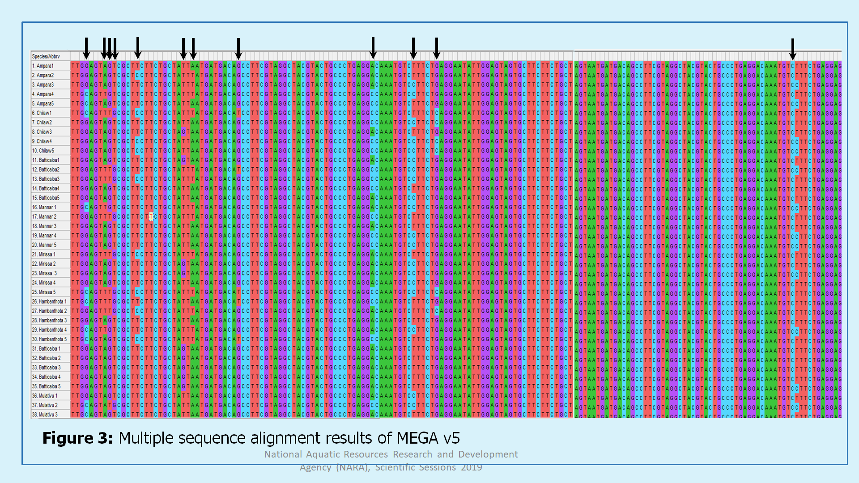

Figure 1: Multiple sequence alignment of partial cytochrome-b (cyt-b) region of A. Sirm individuals collected from Sri Lankan coastal waters

